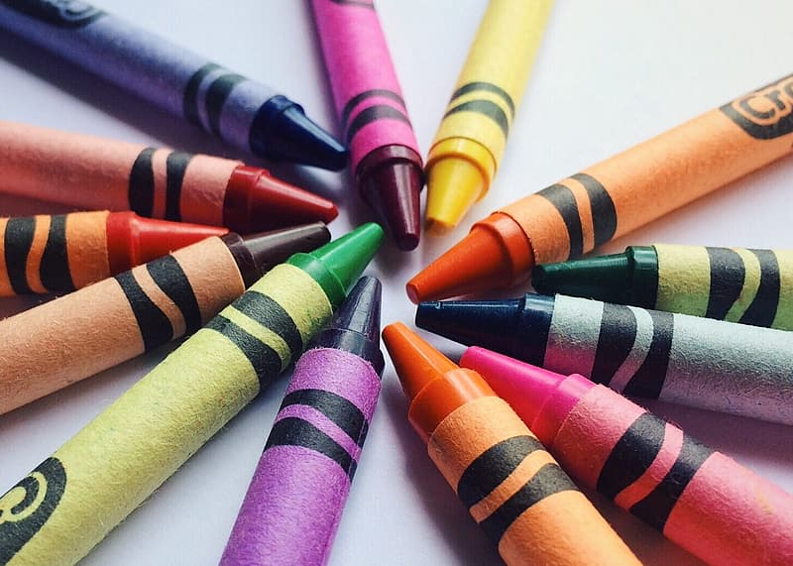
Children’s Books about Colors

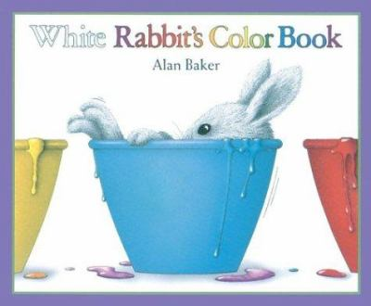
Picture Books:
- Cat’s Colors - Jane Cabrera
- Color Dance- Ann Jonas
- Every Soup Color- Jorey Hurley
- Coat of Many Colors- Dolly Parton
- My Many Colored Days- Dr. Seuss
- White Rabbit’s Color Book- Alan Baker
Board Books:
- Bird Color- Allison Hill Spencer
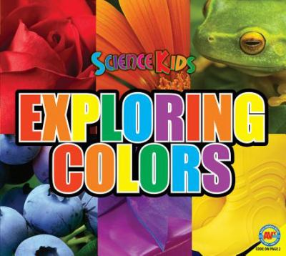
- Football Colors- Mark Weakland
- Duck & Goose Colors- Tad Hills
- Little Owls Colors- Divya Srinivasan
- Shiney Touchy Smelly- Dawn North
- Steam Train, Dream Train Colors- Sherri Duskey Rinker
Non- Fiction:
- Color, Color, Color, Color- Ruth Heller
- Exploring Colors- Aaron Carr

- Colors in Spanish- Daniel Nunn
- Colors- J Clare Beaton

