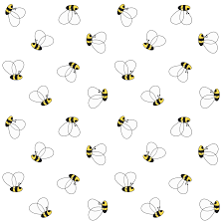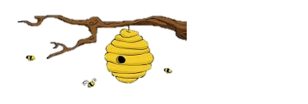

**Children’s Books about BUMBLE BEES**

**Easy Readers**

* *“Buzz,” Said the Bee*- Wendy Lewison
* *Flat Stanley & the Bees*- Jeff Brown
* *Baseball Buzz*- CC Joven
* *Busy Bumblebees*- Mary Elizabeth Salzmann

**Board Books**

* *Bee & Me*- Elle J. McGuinness
* *Bumble Bee*- Margaret Wise Brown

**Non-Fiction**

* *Bees Matter*- Erika Wassall
* *The Bee Book* - Fergus Chadwick
* *How Bees Make Honey*- Louise Spilsbury
* *Look Inside a Bee Hive*- Megan Cooley
* *Dancing Bees*- Mary Lindeen
* *Winter Bees & Other Poems of the Cold*- Joyce Sidman
* *The Buzz on Bees*- Shelley Rotner
* *The Honey Bee’s Hive*- Joyce Markovics
* *The Hive Detectives*- Loree Griffin Burns
* *Plant Parts Smarts*- Eric Braun
* *The Bumblebee Queen*- Patricia J. Wynne

**Picture Books**

* *Bee & Bird*- Craig Frazier
* *The Bee Tree*- Patricia Polacco
* *Bee-Wigged*- Cece Bell
* *The Very Greedy Bee*- Steve Smallman
* *The Raccoon & the Bee Tree*- Charles A. Eastman
* *Do Bees poop?*- Thomas K. Troupe
* *“Buzz,Buzz,Buzz” Went Bumblebee*- Colin West
* *The Beeman*- Laurie Krebs
* *Big Bug Surprise*- Julia Gran
* *Buzz*- Eileen Spinelli
* *Ladybug Girl & Bumblebee Boy*- David Soman
* *Bumblebee, Bumblebee, Do You Know Me?*- Anne Rockwell

**Juvenile**

* *Why I’m Afraid of Bees*- R.L. Stine
* *The Case of the Double Bumble Sting-* John R. Erickson