Children’s Books about Cookies
Board Books:
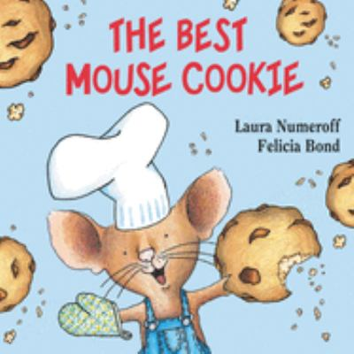
- The Best Mouse Cookies- Laura Joffe Numeroff
Easy Readers:
- Arthur’s Christmas Cookies- Lillian Hoban
- The Little Cookie- Margaret Hillert
- The Christmas Cookie Case- Maria S. Barbo
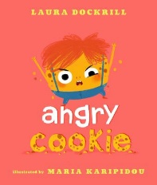
- The Biggest Cookie in the World- Linda Hayward
Picture Books:
- Angry Cookie- Laura Dockrill
- Calling All Cookies!- Charles M. Schultz
- No More Cookies!- Paeony Lewis
- The Cow Loves Cookies- Karma Wilson
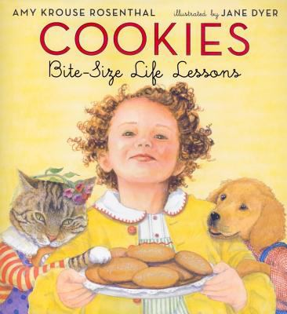
- Mr. Cookie Baker- Monica Wellington
- Who Put the Cookies in the Cookie jar?- George Shannor
- Cookies! Bite-size Life Lessons- Amy Krouse Rosenthal
- Gus and Grandpa and the Christmas Cookie- Claudia Mills
- Bad Boys Get Cookie!- Margie Palatini
- Happy Birthday, Cookie Monster!- Felice Haus
- Detective Ted and The Case Of The Missing Cookie- Melanie Joyce
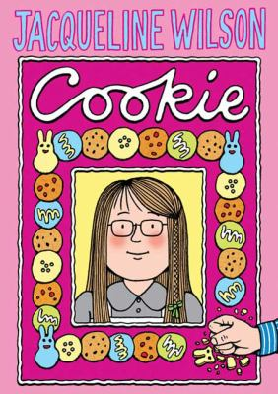
- The Cookie-Store Cat- Cynthia Rylant
- The Duckling Gets a Cookie!?- Mo Willems
- If You Give a Mouse a Cookie- Laura Joffe Numeroff
- Who Ate All the Cookie Dough?- Karen Beaumont
- The Great Spring Cookie Hunt - Harriet Margolin
Juvenile:
- Cookie- Jacqueline Wilson
- The Bride of Frankenstein Doesn’t Bake Cookies- Debbie Dadey
- The Mystery in the Fortune Cookie- Gertrude Chandler Warner
- That’s The Way The Cookie Crumbles- Anne Mazer
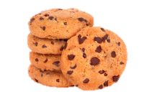
- Heidi Heckelbeck and the Cookie Contest- Wanda Coven
- Like Pickle Juice on a Cookie- Julie Sternberg

