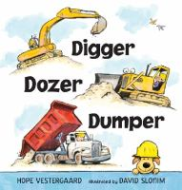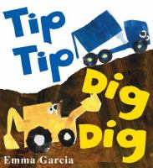

Picture Books:

* *Tip Tip Dig Dig-* Emma Garcia
* *The Construction Crew-* Lynn Meltzer
* *Go! Go! Go! Stop!-* Charise Mericle Harper
* *Pete the Cat: Construction Destruction-* James Dean
* *Little Excavator-* Anna Dewdney
* *Road Work Ahead-* Anastasia Suen
* *Digger, Dozer, Dumper-* Hope Vestergaard
* *Dinosaur Dig-* Penny Dale
* *Dalmatian in a Digger-* Rebecca Elliott
* *Goodnight, Goodnight,   
  Construction Site-* Sherri Duskey Rinker
* *Little Excavator-* Anna Dewdney

Children’s Books about  
 Construction

Non-Fiction:

* *Construction Workers-* Cari Meister
* *Big Machines Build!-* Joe Rhatigan